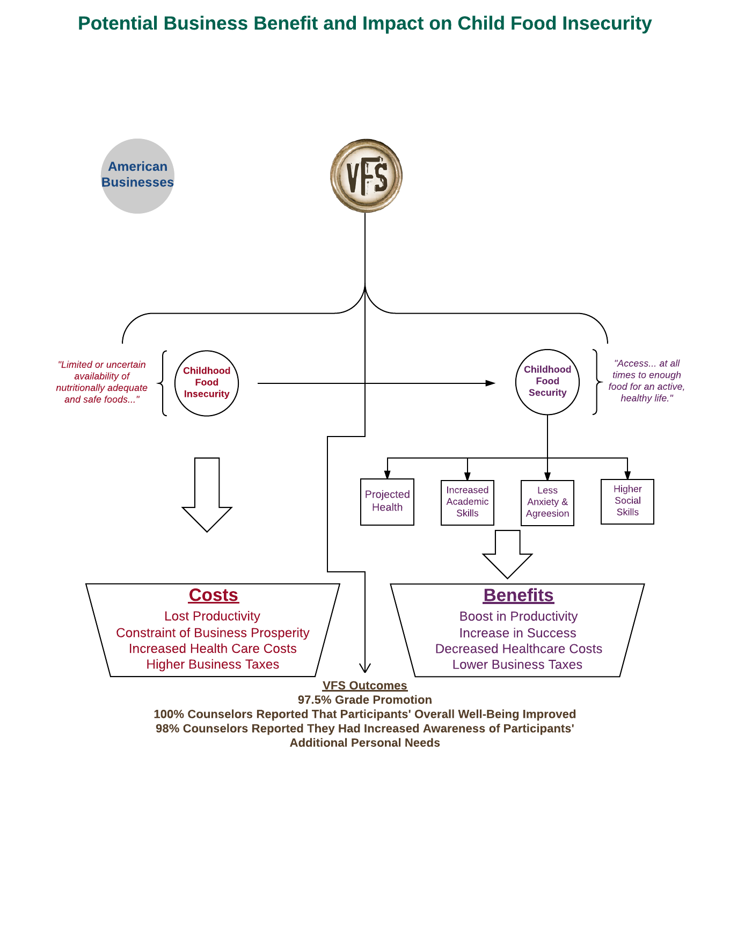

**Vineyard Family Services P.O. Box 2458 Alabaster, AL 35007**



**Stephanie Grissom, Program Director stephiegrissom@gmail.com**

**(205) 317-9897**