GIVE ME 5 HYGIENE DRIVE
(To benefit BackPack Buddies)

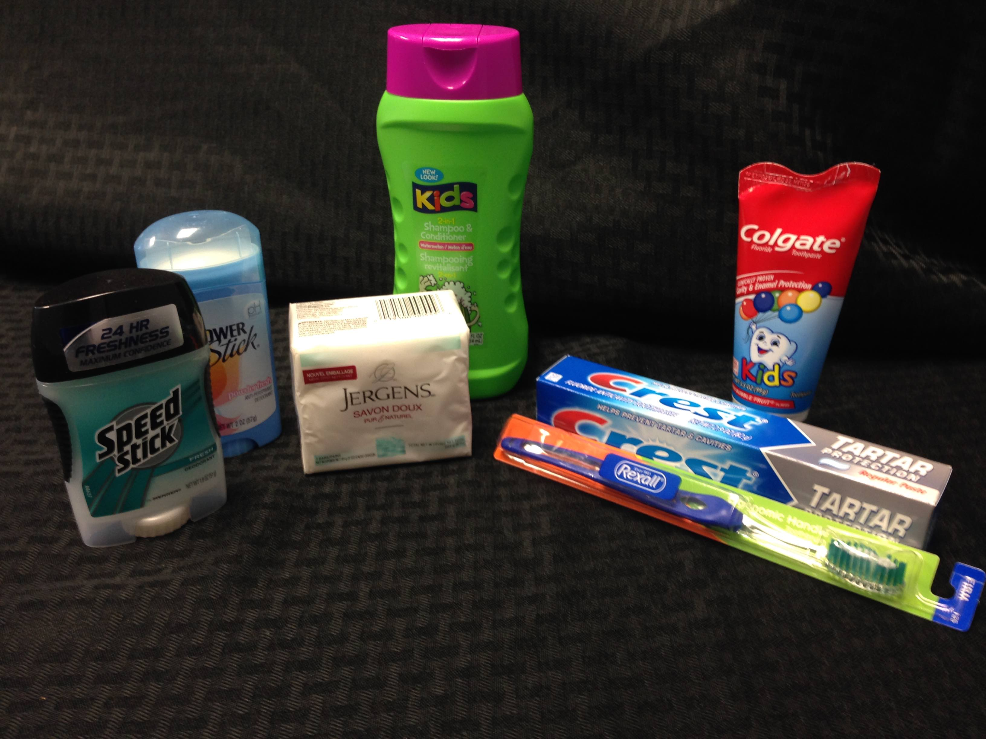

ITEMS NEEDED: (All Adult Size Please)
1. Deodorant
2. Shampoo
3. Soap
4. Toothbrush
5. Toothpaste

All items can be purchased at The Dollar Store!

